**Problem 1**

In this problem, we will examine the sugar content of several national brands of cereals, here measured as a percentage of weight.

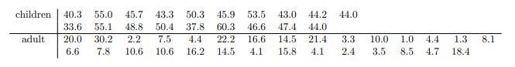

(a) Give a summary of these two data sets.

(b) Create boxplots for Children and Adult sugar content and interpret what you see.

(c) Test the hypothesis to determine if there is a difference in the mean sugar content of children and adult. Use R to create a 95% confidence interval for the difference in mean sugar content and explain your result

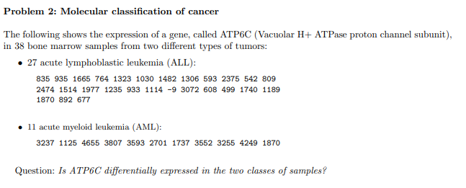

**Problem 3**

